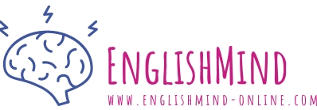
VOCABULARY - IDIOMS

ENGLISH | TRANSLATION
- I have a bone to pick with you. | …………………………………………………………………………
- My slate is clean. | …………………………………………………………………………
- Don't you have bigger fish to fry. | …………………………………………………………………………
- I see that you're sticking to your guns. | …………………………………………………………………………
- I've had my eye on you. | …………………………………………………………………………
- I'm calling your bluff. | …………………………………………………………………………
- Spill the beans. | …………………………………………………………………………
- Look at me, I'm falling apart. | …………………………………………………………………………
- I don't have a leg to stand on. | …………………………………………………………………………
- I broke someone's heart. | …………………………………………………………………………
- I killed two birds with one stone. | …………………………………………………………………………
- I stabbed a man in the back. | …………………………………………………………………………
- Confession is good for the soul. | …………………………………………………………………………
- I’m laughing my a*s off. | …………………………………………………………………………

- to have a disagreement to discuss with someone
- a fresh start, a new chance
- to have more important or interesting things to do
- to stick to your beliefs even if other people disagree with you
- to watch someone or something carefully
- to tell someone to do what they are threatening to do because you believe will not really do it
- to reveal a secret
- to lose control of your emotions and become unable to deal with a difficult situation
- to be in a situation in which you cannot prove something
- to upset someone very much, especially by letting them know that you do not love them
- to succeed in achieving two things at the same time
- to do something harmful to someone who trusted you
- you will feel relieved when you say the truth about what you did
- to laugh so hard at something you pretty near fall off your chair

1.Confession of an Idiom

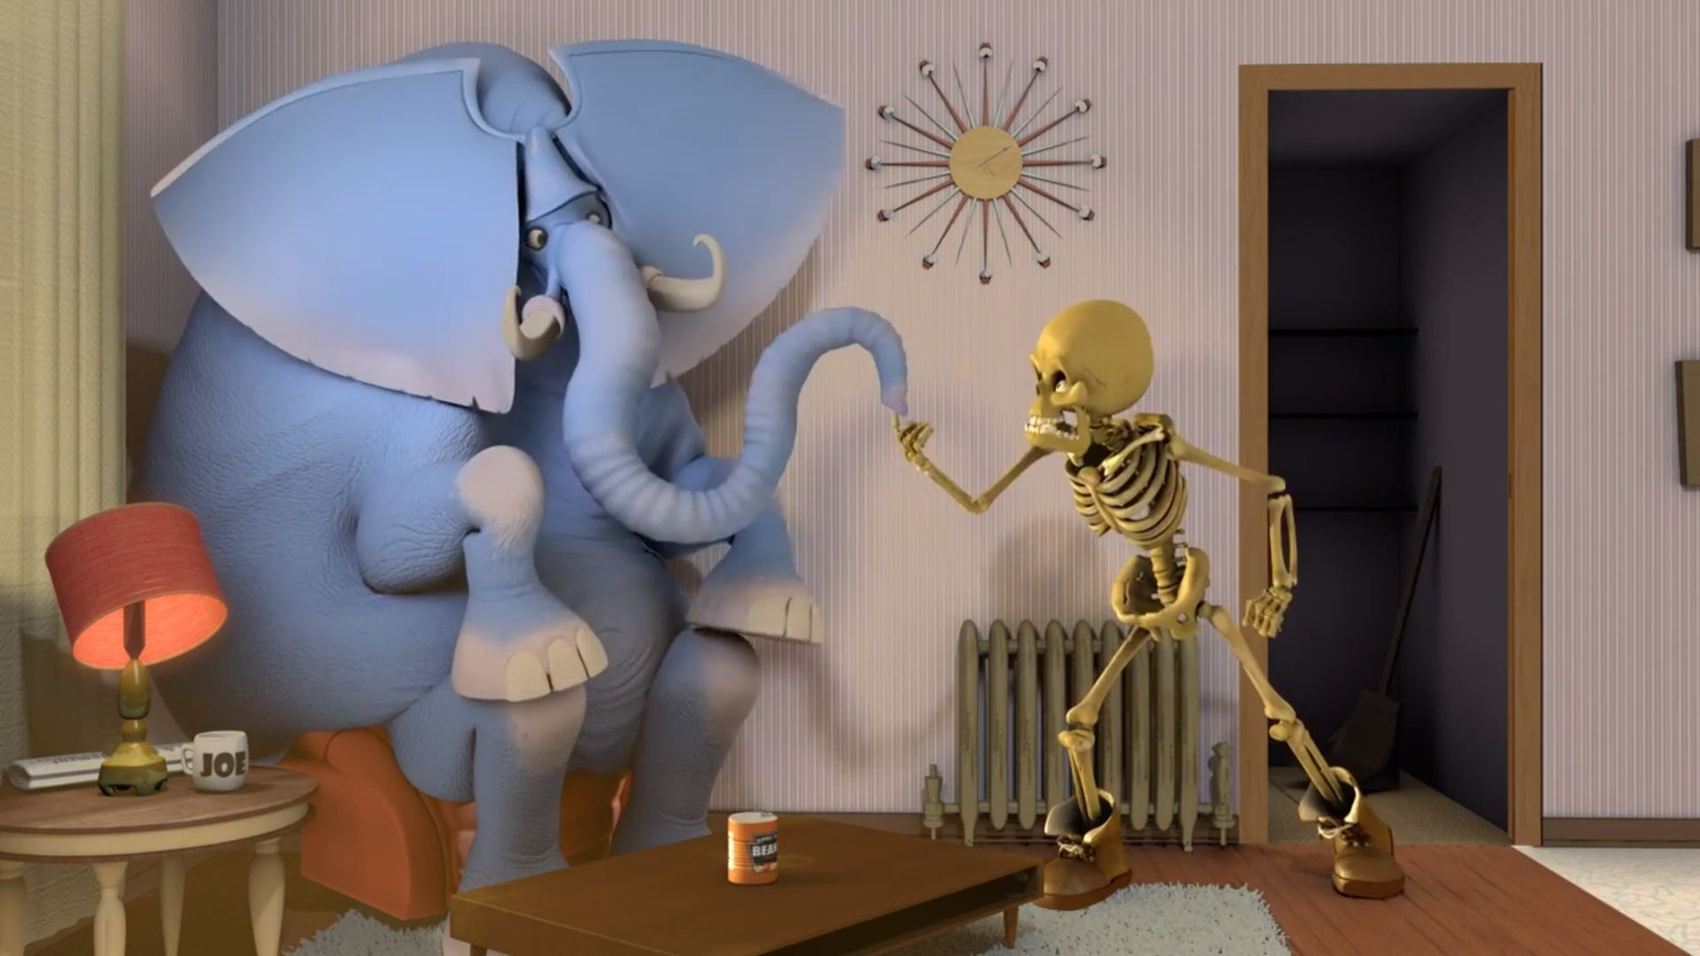

- I have a ________________________ to pick with you.
- My slate is ________________________.
- Don't you have bigger fish to ________________________.
- I see that you're ________________________ to your guns.
- I've had my ________________________ on you.
- I'm ________________________ your bluff.
- Spill the ________________________.
- Look at me ,I'm ________________________ apart.
- I don't have a ________________________ to stand on.
- I ________________________ someone's heart.
- I killed two birds with a ________________________.
- I ________________________ a man in the back.
- ________________________ is good for the soul.
- I’m laughing my ________________________.

Source: https://www.youtube.com/watch?v=flCMjBo6hD0 Created by: https://www.englishmind-online.com

